**Install java in windows**

1. check java install or not first. open command prompt and enter **java -version**

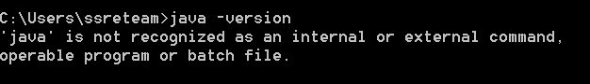

if you see java command not found you must install java in your environment.

2. for download goto below url and accept the license and agreement.

https://www.oracle.com/technetwork/java/javase/downloads/jdk8-downloads-2133151.html

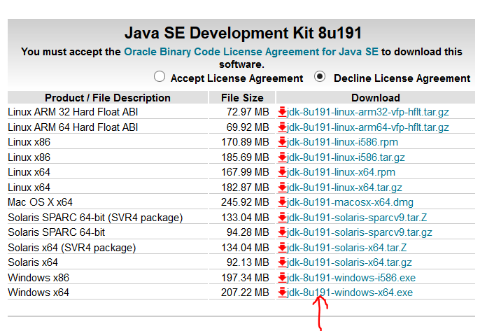

3. After download successfully double click on that the follow next next button. once successfully installed need to set the environment variables JAVA_HOME and path.

4. then goto my computer --> properties -->advance system settings --> Environmental variables -->toyo system settings --> create new variable called JAVA_HOME and give the path where install java in your system and click ok. Then add path check the variable path add the java path in edit path add the end of the line like (%JAVA_HOME%\bin).then check the java -version in new command prompt.

